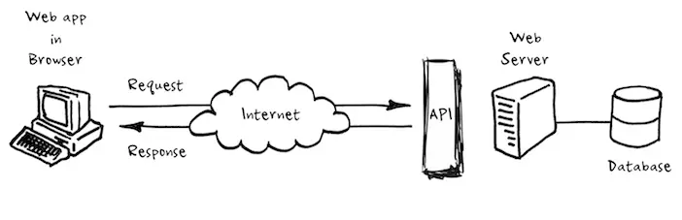**2.1. Phác thảo mô hình công nghệ ứng dụng**

**2.3. Thiết kế dữ liệu**

**2.3.1. Thiết kế sơ đồ quan hệ thực thể**

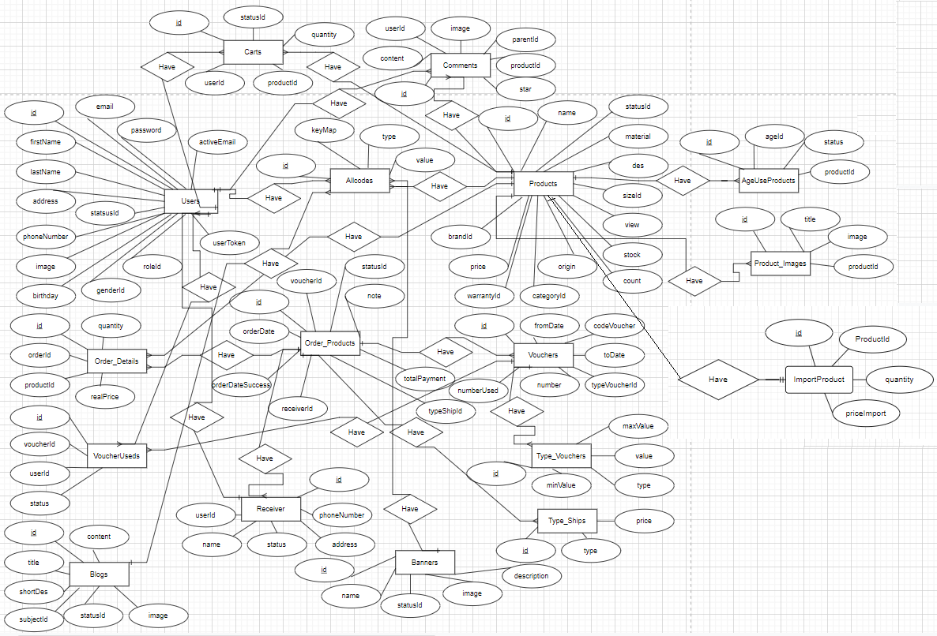**2.3.2. Thiết kế chi tiết thực thể**

Table Users{

id int(11) [pk]

email varchar(255)

password varchar(255)

firstName varchar(255)

lastName varchar(255)

address varchar(255)

birthday varchar(255)

phoneNumber varchar(255)

image longblob

genderId varchar(255)

roleId varchar(255)

statusId varchar(255)

ActiveEmail boolean

userToken varchar(255)

created_at datetime

updated_at datetime

}

Table Allcode {

id int(11) [pk]

keyMap varchar(255)

type varchar(255)

value varchar(255)

created_at datetime

updated_at datetime

}

Table Products {

id int(11) [pk]

name varchar(255)

statusId varchar(255)

categoryId varchar(255)

brandId varchar(255)

warrantyId varchar(255)

origin varchar(255)

material varchar(255)

view varchar(255)

shortDes longtext

long varchar(255)

width varchar(255)

height varchar(255)

weight varchar(255)

sizeId varchar(255)

stock int(11)

count int(11)

nameDetail varchar(255)

originalPrice BIGINT

percentDiscount int(11)

discountPrice BIGINT

desHTML longtext

desMarkdown longtext

created_at datetime

updated_at datetime

}

Table Product_Images {

id int(11) [pk]

title varchar(255)

productId int(11)

image longblob

created_at datetime

updated_at datetime

}

Table Order_Details{

id int(11) [pk]

orderId int(11) [ref: > Order_Products.id]

productId int(11) [ref: > Products.id]

quantity int(11)

realPrice bigint

created_at datetime

updated_at datetime

}

Table Order_Products{

id int(11) [pk]

orderDate varchar(255)

orderDateSuccess varchar(255)

receiverId int(11)

statusId varchar(255)

typeShipId int(11)

voucherId varchar(255)

note varchar(255)

totalPayment BIGINT

created_at datetime

updated_at datetime

}

Table Banners {

id int(11) [pk]

name varchar(255)

statusId varchar(255)

image longblob

description longtext

created_at datetime

updated_at datetime

}

Table Comments {

id int(11) [pk]

content longtext

image longblob

parentId int(11)

productId int(11)

userId int(11)

star int(11)

created_at datetime

updated_at datetime

}

Table Blogs {

id int(11) [pk]

title varchar(255)

shortDes longtext

subjectId varchar(255)

statusId longtext

image longtext

contentMarkdown longtext

contentHTML longtext

created_at datetime

updated_at datetime

}

Table Carts {

id int(11) [pk]

userId int(11) [ref: > Users.id]

productId int(11) [ref: > Products.id]

quantity int(11)

statusId varchar(255)

created_at datetime

updated_at datetime

}

Table Receiver {

id int(11) [pk]

userId int(11)

name varchar(255)

address varchar(255)

phoneNumber varchar(255)

status int(11)

created_at datetime

updated_at datetime

}

Table Vouchers {

id int(11) [pk]

fromDate varchar(255)

toDate varchar(255)

typeVoucherId int(11)

number int(11)

numberUsed int(11)

codeVoucher varchar(255)

created_at datetime

updated_at datetime

}

Table VoucherUseds {

id int(11) [pk]

voucherId int(11) [ref: > Vouchers.id]

userId int(11) [ref: > Users.id]

status int(11)

created_at datetime

updated_at datetime

}

Table Type_Vouchers {

id int(11) [pk]

maxValue bigint

minValue bigint

type varchar(255)

value bigint

created_at datetime

updated_at datetime

}

Table Type_Ships {

id int(11) [pk]

type varchar(255)

price bigint

created_at datetime

updated_at datetime

}

Table AgeUseProducts {

id int(11) [pk]

ageId varchar(255)

productId int(11)

status int(11)

created_at datetime

updated_at datetime

}

Table ImportProducts {

id int(11) [pk]

productId int(11) [ref: > Products.id]

quantity int(11)

priceImport bigint

created_at datetime

updated_at datetime

}

**2.3.3. Thiết kế sơ đồ lớp**

